IRIS OpenSpace
Client Guide
Version 1.1a
Table of Contents
Introduction 3
First Steps 4
Activating your account 4
Logging in 5
Forgotten Password 5
Notifications 6
Navigation 6
Changing your user details 7
To change your email address 7
To change your password 7
Where to find help 8

Introduction
You have had an account created on IRIS OpenSpace so that we can exchange documents instantly and securely.
With IRIS OpenSpace you can access your files from any location - just fire up an internet browser and login.
Improve business resilience; protect your company from disaster or weather-related disruption, all your files are stored securely off site so you can get access to them quickly and effectively.
This guide is to help you get started with using IRIS OpenSpace. If you require any further help please contact:
[INSERT NAME HERE]
Tel: [0000-000-000]
e-mail: [email@address.com]

Before you send this document:
- This document can be customised for your business with your website, logo, font and colours.
- It is recommended, if you are rebranding, that you replace all the screenshots.
- Items in [TEXT] are required to be completed before sending this document to your clients.
- If you make changes please remember to update the table of contents.
- IRIS Support cannot provide help to your clients directly.
- Please leave the copyright and final paragraph at the end of this document.
Delete this text box before sending to your client.

First Steps

Activating your account
We have sent you an email (pictured below) asking you to activate your account and allowing you to create your own password.
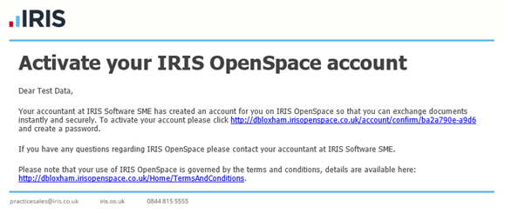
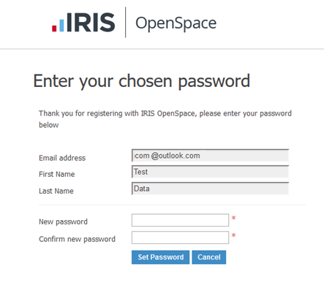
Click on the link in the email, check the details and create a password. You will need to confirm the password. Once this is complete please click Set Password. You can change this password at any time. Your password is encrypted and securely stored on the IRIS OpenSpace website, no one has access to this password other than you.

Your password must contain at least one letter and one number

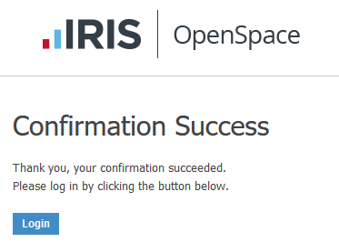
You will see a conformation screen once the password has been set.

Logging in
Once you have created your account you can log in from any computer with a web browser. Just visit www.irisopenspace.co.uk [insert domain or subdomain if different], enter your email address and password.
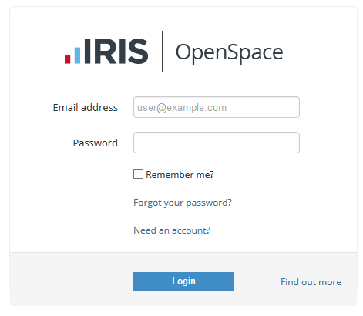
Once you log in for the first time you will be prompted to agree to the terms and conditions.

Forgotten Password
If you have forgotten your password please click the link forgot your password or visit https://www.irisopenspace.co.uk/Account/PasswordReset where you will be asked to enter the email address used when the account was created.
You will then receive an email with a unique link where you can create a new password.
Your password must contain at least one letter and one number

Notifications
When a file is sent to IRIS OpenSpace you will receive an email (pictured below)
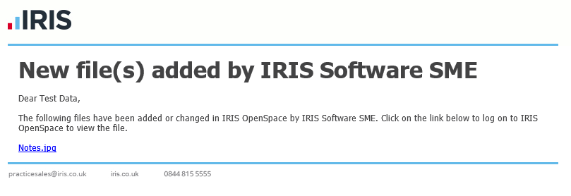
You can access the file in a number of ways.
- Click the link contained within the email
- Visit the website and enter your log in details

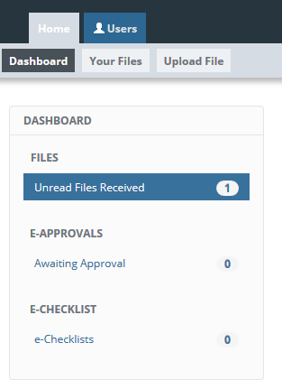
Navigation

Changing your user details
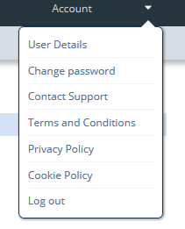
You can change your email address, password at any time. These options are available at the top of each page. Click the word account or the arrow at the top of the screen to access the menu.

To change your email address
Click on User Details item from the menu
Enter your new email address and click update.
If you choose to change your e-mail address, you will be logged out and will have to log in using the new address you enter here.

To change your password
Click on the Change password item from the menu
Enter your current password, new password and confirm the password then click update.
Your password must contain at least one letter and one number

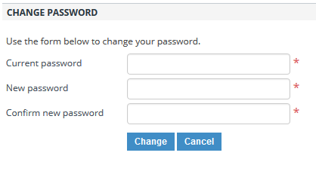

Where to find help
If you have any questions or need help please contact:
[INSERT NAME HERE]
Tel: [0000-000-000]
e-mail: [email@address.com]

Please note that your use of IRIS OpenSpace is governed by the terms and conditions, details are available here: https://www.irisopenspace.co.uk/Home/TermsAndConditions

